CAR RENTAL BOOKING

DONE BY

SHYAM KUMAR P

ABSTRACTION

Car rental is when you rent a car. The company providing you the car becomes the car rental service provider, whereas you become the car hirer, as you hire the car for a fee.

A car rental agency or a rent-a-car  is a company that rents [automobiles](https://simple.wikipedia.org/wiki/Automobile) for short periods of time (ranging from a few hours to a few weeks) for a [fee](https://simple.wikipedia.org/wiki/Fee).

Car rental agencies are mainly for people who need a car for a short period of time, for example [travellers](https://simple.wikipedia.org/wiki/Travel) who are out of town, people whose cars were damaged or destroyed. Car rental agencies may also rent trucks for self-[moving industry](https://simple.wikipedia.org/w/index.php?title=Moving_industry&action=edit&redlink=1).

Car rentals are subject to many conditions which vary from one [brand](https://simple.wikipedia.org/wiki/Brand) to another. The vehicle must be returned in a good condition and must not exceed a maximum driven distance, otherwise extra fees may be incurred.[[1]](https://simple.wikipedia.org/wiki/Car_rental#cite_note-1) Additionally, some companies set up a minimum age for the vehicle driver, which in some cases is as high as 25, even in countries where the minimum legal age to hold a [driver's license](https://simple.wikipedia.org/wiki/Driver%27s_license) is much lower. Recent conditions have used [GPS](https://simple.wikipedia.org/wiki/GPS) technology to limit maximum speeds or driving to specific regions.

1.LOGIN.jsp

Programs:

<%@page contentType="text/html" pageEncoding="UTF-8"%>

<!DOCTYPE html>

<html>

<head>

<meta http-equiv="Content-Type" content="text/html; charset=UTF-8">

<title>JSP Page</title>

</head>

<body background="images/background.jpg" style = "background-repeat:no-repeat; background-size:100% 120%" >

<div align="right">

<form action="car.jsp" method="POST">

<table style="border: solid green; border-spacing:40px; opacity: 1; background-color: whitesmoke">

<tr><td>

<h1 style="color: blue"> LOGIN PAGE </h1>

<div style="text-align:left ">

<input type="text" name="user" value="" placeholder=" Username"/><br/><br/>

<input type="password" name="pass" value="" placeholder="Password"/><br/><br/>

</div>

<input type="submit" value="SUBMIT" />

<div style="text-align: center">

<a href="register.jsp" style="color:red"><h3>NEW USER</h3></a></div>

</td></tr></table>

</form>

</div>

</body>

<br><br><br><br><br><br><br><br><br><br><br><br><br><br><br><br><br><br><br><br><br><br><br><br><br><br><br>

</html>

Output:

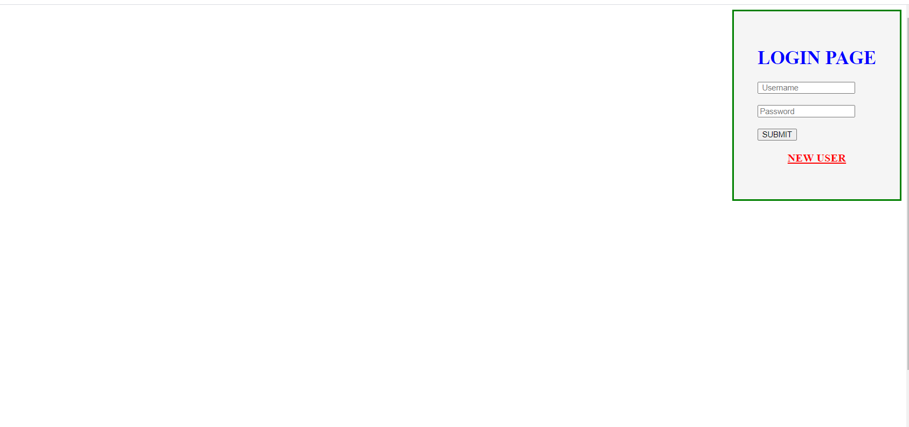

2.Logindao.jsp

Programs:

<%@page contentType="text/html" pageEncoding="UTF-8"%>

<!DOCTYPE html>

<html>

<head>

<meta http-equiv="Content-Type" content="text/html; charset=UTF-8">

<title>Registration Page</title>

</head>

<body background="images/background3.jpeg" style = "background-repeat:no-repeat; background-size:100% 130%" >

<div align="center">

<h1 style="color: blue">Register Form</h1>

<form action="registrationdao" method="post">

<table style="border: solid seashell; border-spacing: 18px; width: 17%; opacity: 1; background-color: seashell">

<tr><td>

<div align="left">

Username : <br><input type="text" name="user" value="" required="" autofocus=""/><br><br>

Password : <br><input type="password" name="npass" value="" required="" /><br><br>

Confirm Password : <br><input type="password" name="rpass" value="" required=""/><br><br>

Phone Number : <br><input type="text" name="phone" value="" required="" /><br><br>

Email-id : <br><input type="text" name="email" value="" required=""/><br><br>

Address :<br> <textarea name="address" rows="4" cols="20" required="" ></textarea><br><br>

</div>

Aadhar Card : <input type="file" name="Aadhar Card" value="" /><br><br>

Pan Card : <input type="file" name="Pan Card" value="" /><br><br>

<div align="center">

<input type="submit" value="SUBMIT" />&nbsp;&nbsp;&nbsp;

<input type="reset" value="RESET" /></div>

</td></tr>

</table>

</form>

</div>

</body><br><br><br><br><br><br><br><br><br><br><br><br>

</html>

Output:

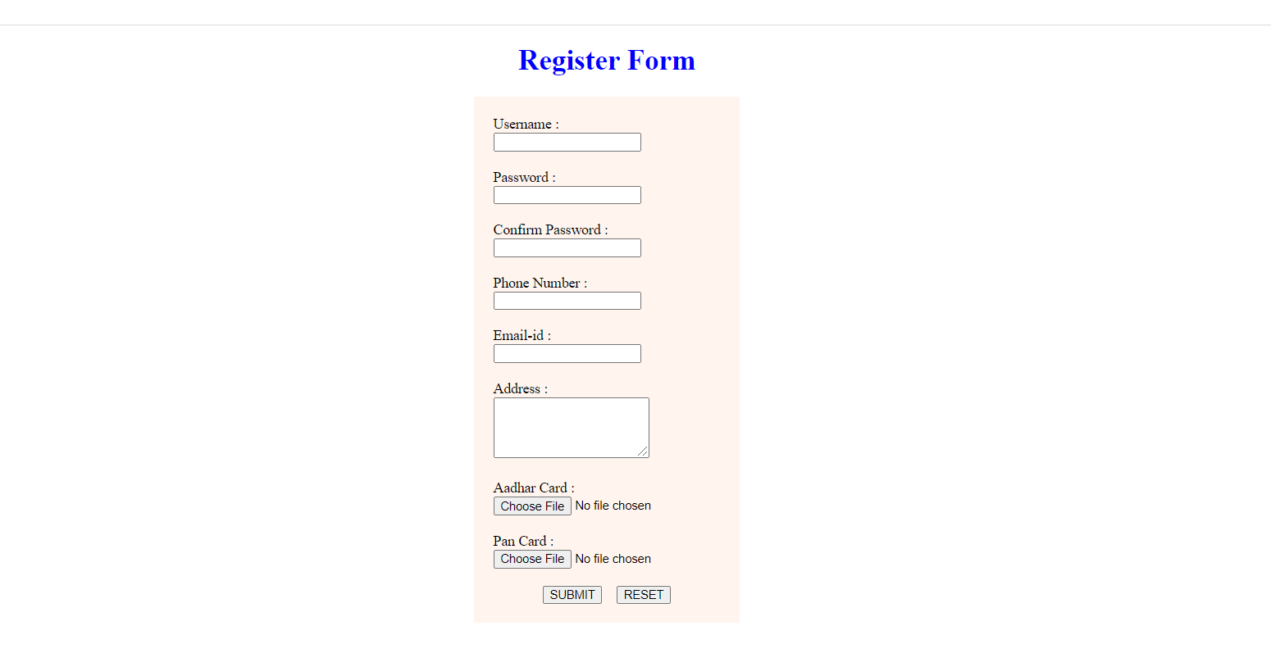

3. Car.jsp

<%@page contentType="text/html" pageEncoding="UTF-8"%>

<%@taglib prefix="c" uri="http://java.sun.com/jsp/jstl/core"%>

<!DOCTYPE html>

<html>

<head>

<meta http-equiv="Content-Type" content="text/html; charset=UTF-8">

<title>CAR RENTAL</title>

</head>

<body>

<center>

<form action='<c:url value="/SessionServlet"/>' name="myform" method="post">

<table style="border: none; border-spacing: 50px; opacity: 0.8; background-color:buttonface"><tr>

<td><img src='images/1mercedes' name="Car" value="MercedesBenzVClass" width='100' height='100'/>

<details><c:set var="MercedesBenzVClass" value="55000"/>Price : <c:out value="${MercedesBenzVClass}"/><br>

<c:set var="MercedesBenzVClass" value="Mercedes-Benz V-Class"/>Name : <c:out value="${MercedesBenzVClass}"/></details><br/></td>

<td><img src='images/2lkiacarnival' name="Car" value="KiaCarnival" width='100' height='100' />

<details><c:set var="Kiacarnival" value="30000"/>Price : <c:out value="${Kiacarnival}"/><br>

<c:set var="Kiacarnival" value="Kia Carnival"/>Name : <c:out value="${Kiacarnival}"/></details><br/></td>

<td><img src='images/3marutiertigap' name="Car" value="MarutiErtiga" width='100' height='100'/>

<details><c:set var="MarutiErtiga" value="20000"/>Price : <c:out value="${MarutiErtiga}"/><br>

<c:set var="MarutiErtiga" value="Maruti Ertiga"/>Name : <c:out value="${MarutiErtiga}"/></details><br/></td>

<br><br>

<td><img src='images/4toyotainnovacrystal' name="Car" value="ToyotaInnovaCrystal" width='100' height='100'/>

<details><c:set var="ToyotaInnovaCrystal" value="40000"/>Price : <c:out value="${ToyotaInnovaCrystal}"/><br>

<c:set var="ToyotaInnovaCrystal" value="Toyota Innova Crystal"/>Name : <c:out value="${ToyotaInnovaCrystal}"/></details><br/></td>

<td><img src='images/5renaulttber' name="Car" value="RenaultTriber" width='100' height='100'/>

<details><c:set var="RenaultTriber" value="40000"/>Price : <c:out value="${RenaultTriber}"/><br>

<c:set var="RenaultTriber" value="Renault Triber"/>Name : <c:out value="${RenaultTriber}"/></details><br/></td>

<td><img src='images/6teslamodelx' name="Car" value="TeslaModelX" width='100' height='100'/>

<details><c:set var="TeslaModelX" value="45000"/>Price : <c:out value="${TeslaModelX}"/><br>

<c:set var="TeslaModelX" value="Tesla Model X"/>Name : <c:out value="${TeslaModelX}"/></details><br/></td>

<td><img src='images/7.minicooper' name="Car" value="MiniCooper" width='100' height='100'/>

<details><c:set var="MiniCooper" value="60000"/>Price : <c:out value="${MiniCooper}"/><br>

<c:set var="MiniCooper" value="Mini Cooper"/>Name : <c:out value="${MiniCooper}"/></details><br/></td>

<td><img src='images/8tatatiago' name="Car" value="TATaTiago" width='100' height='100'/>

<details><c:set var="TATaTiago" value="55000"/>Price : <c:out value="${TATaTiago}"/><br>

<c:set var="TATaTiago" value="TATa Tiago"/>Name : <c:out value="${TATaTiago}"/></details><br/></td>

<td><img src='images/9Maruti' name="Car" value="MarutiEeco" width='100' height='100'/>

<details><c:set var="MarutiEeco" value="40000"/>Price : <c:out value="${MarutiEeco}"/><br>

<c:set var="MarutiEeco" value="Maruti Eeco"/>Name : <c:out value="${MarutiEeco}"/></details><br/></td>

<td><img src='images/10audi' name="Car" value="Audi" width='100' height='100'/>

<details><c:set var="Audi" value="45000"/>Price : <c:out value="${Audi}"/><br>

<c:set var="Audi" value="Audi"/>Name : <c:out value="${Audi}"/></details><br/></td><br>

</tr></table>

<table style="border: none; border-spacing: 50px; opacity: 0.8; background-color:buttonface"><tr>

<td><img src='images/11marutisuzukispresso' name="Car" value="MarutiSuzutiSPress0LX" width='100' height='100'/>

<details><c:set var="MarutiSuzutiSPresso LX" value="45000"/>Price : <c:out value="${MarutSuzutiSPressoLX}"/><br>

<c:set var="MarutiSuzutiSPresso LX" value="Maruti Suzuti S-Presso LX"/>Name : <c:out value="${MarutiSuzutiSPress0LX}"/></details><br/></td>

<td><img src='images/12mahithar' name="Car" value="MahindraThar" width='100' height='100'/>

<details><c:set var="MahindraThar" value="25000"/>Price : <c:out value="${MahindraThar}"/><br>

<c:set var="MahindraThar" value="Mahindra Thar"/>Name : <c:out value="${MahindraThar}"/></details><br/></td>

<td><img src='images/13mahi300' name="Car" value="Mahindra XUV300" width='100' height='100'/>

<details><c:set var="MahindraXUV300" value="25000"/>Price : <c:out value="${MahindraXUV300}"/><br>

<c:set var="MahindraXUV300" value="Mahindra XUV300"/>Name : <c:out value="${MahindraXUV300}"/></details><br/></td>

<td><img src='images/14mahiscorpio' name="Car" value="MahindraScorpio" width='100' height='100'/>

<details><c:set var="MahindraScorpio" value="30000"/>Price : <c:out value ="${MahindraScorpio}"/><br?

<c:set var="MahindraScorpio" value="Mahindra Scorpio"/>Name : <c:out value="${MahindraScorpio}"/></details><br/></td>

<td><img src='images/15mahi500' name="Car" value="MahindraXUV500" width='100' height='100'/>

<details><c:set var="MahindraXUV500" value="28000"/>Price : <c:out value="${MahindraXUV500}"/><br>

<c:set var="MahindraXUV500" value="Mahindra XUV500"/>Name : <c:out value="${MahindraXUV500}"/></details><br/></td>

<td><img src='images/16toyafortuner' name="Car" value="ToyotaFortuner" width='100' height='100'/>

<details><c:set var="ToyotaFortuner" value="35000"/>Price : <c:out value="${ToyotaFortuner}"/><br>

<c:set var="ToyotaFortuner" value="Toyota Fortuner"/>Name : <c:out value="${ToyotaFortuner}"/></details><br/></td>

<td><img src='images/17toyainnovacrystal' name="Car" value="ToyotaInnovaCrystal" width='100' height='100'/>

<details><c:set var="ToyotaInnovaCrystal" value="28000"/>Price : <c:out value="${ToyotaInnovaCrystal}"/><br>

<c:set var="ToyotaInnovaCrystal" value="Toyota Innova Crystal"/>Name : <c:out value="${ToyotaInnovaCrystal}"/></details><br/></td>

<td><img src='images/18toyaglanza' name="Car" value="Toyota Glanza" width='100' height='100'/>

<details><c:set var="ToyotaGlanza" value="50000"/>Price : <c:out value="${ToyotaGlanza}"/><br>

<c:set var="ToyotaGlanza" value="Toyota Glanza"/>Name : <c:out value="${ToyotaGlanza}"/></details><br/></td>

<td><img src='images/19rolls' name="Car" value="RollsRoyceMotor" width='100' height='100'/>

<details><c:set var="RollsRoyceMotor" value="40000"/>Price : <c:out value="${RollsRoyceMotor}"/><br>

<c:set var="RollsRoyceMotor" value="Rolls-Royce Motor"/>Name : <c:out value="${RollsRoyceMotor}"/></details><br/></td>

<td><img src='images/20lambo' name="Car" value="Lamborghini" width='100' height='100'/>

<details><c:set var="Lamborghini" value="50000"/>Price : <c:out value="${Lamborghini}"/><br>

<c:set var="Lamborghini" value="Lamborghini"/>Name : <c:out value="${Lamborghini}"/></details><br/></td>

</tr></table></form>

<br><br><br><br><br>

<form action='<c:url value="/SessionServlet"/>' name='MyForm' method='POST'>

<table style="border: solid seashell; border-spacing: 15px; opacity: 1; background-color: seashell"> <tr>

<td bordercolor='white'><font color='darkorange'> Select Item From Above : </font></td>

<td bordercolor='white'>

<select name='Bike'>

<option value='CFCMoto650GT'>CFCMoto 650GT</option>

<option value='BMWF900R'>BMW F900 R</option>

<option value='RoyalEnfieldClassic350'>Royal Enfield Classic350</option>

<option value='YamahaMT15'>Yamaha MT 15</option>

<option value='RoyalEnfieldBullet350'>Royal Enfield Bullet350</option>

<option value='TVSApacheRTR160'>TVS Apache RTR 160</option>

<option value='BajajPulsarNS200'>Bajaj Pulsar NS200</option>

<option value='TVSApacheRTR1604V'>TVS Apache RTR 160 4V</option>

<option value='YamahaFZSF1V3'>Yamaha FZS-F1 V3</option>

<option value='BajajPulsar220F'>Bajaj Pulsar 220F</option>

<option value='BMWR1250GS'>BMW R 1250 GS</option>

<option value='BMWR1250GSAdventure'>BMW R 1250 GS Adventure</option>

<option value='BMWR1250R'>BMW R 1250 R</option>

<option value='YamahaYZFR15V3'>Yamaha YZF R15 V3</option>

<option value='RoyalEnfieldHimalayan'>Royal Enfield Himalayan</option>

<option value='RoyalEnfieldContinentalGT650'>Royal Enfield Continental GT 650</option>

<option value='YamahaFZFiVersion3'>Yamaha FZ-Fi Version 3</option>

<option value='Jawa42'>Jawa 42</option>

<option value='KTM125Duke'>KTM 125 Duke</option>

<option value='KTM390DUKE'>KTM 390 DUKE</option>

</select>

<tr>

<td bordercolor='white'><font color='darkorange'> Enter the Date : </font> </td><td bordercolor='white'>

<input type= 'date' name='Date' required="" autofocus=""></td> </tr>

<tr>

<td bordercolor='white'><font color='darkorange'> Enter the No of Days : </font> </td><td bordercolor='white'>

<input type= 'number' name='Days' required="" autofocus=""></td> </tr> <tr><td align="center">

<input type='hidden' value='sBike' name='PageName'/> </td> </tr> <tr><td bordercolor='white'>

<input type='submit' Value='Next'></input></td>

</tr></table></form>

</center>

</body>

<br><br><br><br><br><br>

<jsp:include page="footer.jsp"></jsp:include>

</html>

</body>

</html>

Output:

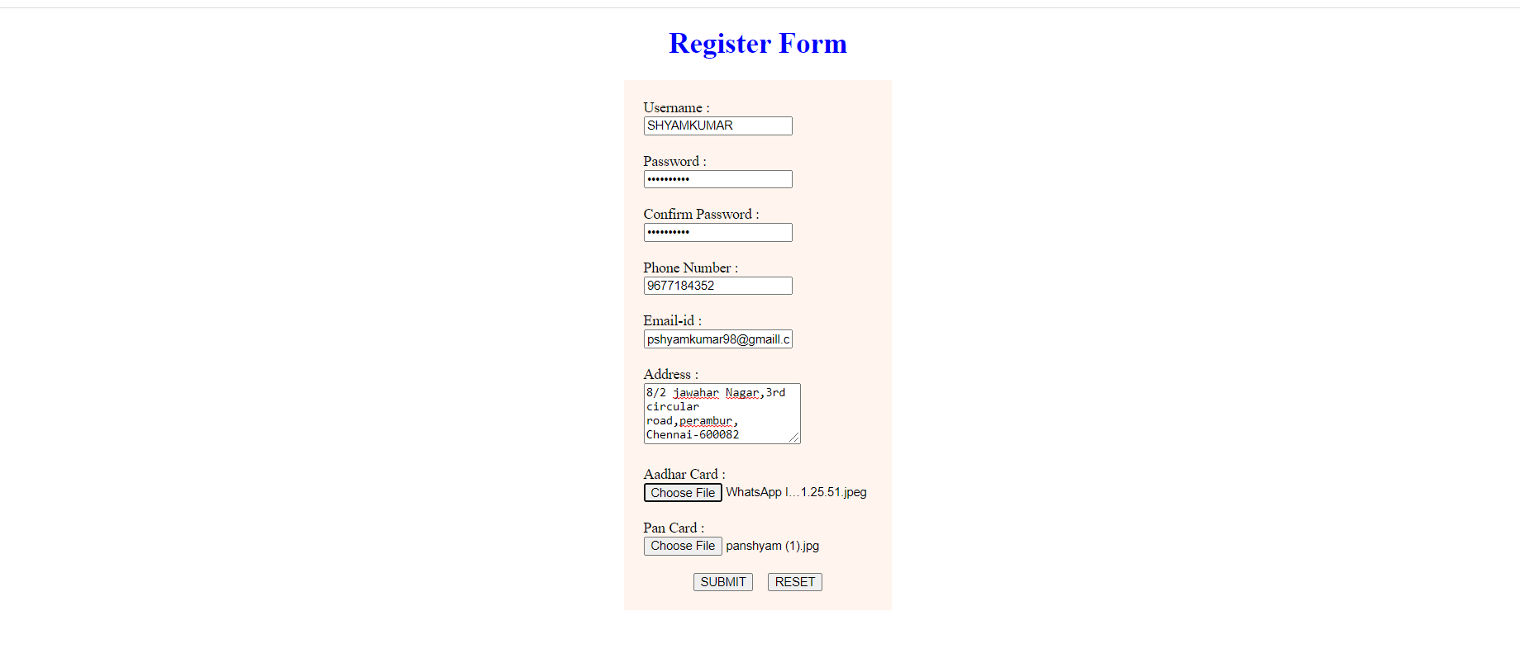

4. Registration.jsp

package control;

import java.io.IOException;

import java.io.PrintWriter;

import javax.servlet.RequestDispatcher;

import javax.servlet.ServletException;

import javax.servlet.annotation.WebServlet;

import javax.servlet.http.HttpServlet;

import javax.servlet.http.HttpServletRequest;

import javax.servlet.http.HttpServletResponse;

/**

*

* @author ELCOT

*/

@WebServlet(name = "Regsiterval", urlPatterns ={"/Registerval"})

public class Regsiterval extends HttpServlet {

protected void processRequest(HttpServletRequest request, HttpServletResponse response)

throws ServletException, IOException {

response.setContentType("text/html;charset=UTF-8");

try (PrintWriter out = response.getWriter()) {

String np=request.getParameter("Npass");

String rp=request.getParameter("Rpass");

Register res=new Register(np,rp);

if(res.val())

{

RequestDispatcher rd=request.getRequestDispatcher("Login.jsp");

out.println("<center>");

out.printf("<h2 style='color:green'>Registration Successfull</h2>");

out.printf("</center>");

rd.include(request,response);

}

else

{

RequestDispatcher rd=request.getRequestDispatcher("regerror.jsp");

rd.include(request,response);

}

}

}

// <editor-fold defaultstate="collapsed" desc="HttpServlet methods. Click on the + sign on the left to edit the code.">

/**

* Handles the HTTP <code>GET</code> method.

*

* @param request servlet request

* @param response servlet response

* @throws ServletException if a servlet-specific error occurs

* @throws IOException if an I/O error occurs

*/

@Override

protected void doGet(HttpServletRequest request, HttpServletResponse response)

throws ServletException, IOException {

processRequest(request, response);

}

/**

* Handles the HTTP <code>POST</code> method.

*

* @param request servlet request

* @param response servlet response

* @throws ServletException if a servlet-specific error occurs

* @throws IO Exception if an I/O error occurs

*/

@Override

protected void doPost(HttpServletRequest request, HttpServletResponse response)

throws ServletException, IOException {

processRequest(request, response);

}

/**

* Returns a short description of the servlet.

*

* @return a String containing servlet description

*/

@Override

public String getServletInfo() {

return "Short description";

}// </editor-fold>

}

5.Template.jsp:

Program:

<%@page contentType="text/html" pageEncoding="UTF-8"%>

<!DOCTYPE html>

<html>

<head>

<meta http-equiv="Content-Type" content="text/html; charset=UTF-8">

<title>CAR RENTAL</title>

</head>

<body>

<br><br/><br/><br/><br/>

<style>

body{

height: 100%;

background-image: url('images/b1.png');

background-repeat: no-repeat;

background-size: 100% 130%;

}

</style>

<style>

::-webkit-scrollbar{

width: 10px;

}

::-webkit-scrollbar-track{

background: black;

}

::-webkit-scrollbar-thumb{

background: whitesmoke;

}

::-webkit-scrollbar-thumb:hover{

background: #ffff99;

}

</style>

</body>

</html>

Output:



6.logindao.java:

Program:

package control;

import java.io.IOException;

import java.io.PrintWriter;

import java.sql.Connection;

import java.sql.DriverManager;

import java.sql.PreparedStatement;

import java.sql.ResultSet;

import java.sql.SQLException;

import javax.servlet.RequestDispatcher;

import javax.servlet.ServletException;

import javax.servlet.annotation.WebServlet;

import javax.servlet.http.HttpServlet;

import javax.servlet.http.HttpServletRequest;

import javax.servlet.http.HttpServletResponse;

/**

*

* @author shyam kumar P

*/

@WebServlet(name = "Logindao", urlPatterns = {"/Logindao"})

public class Logindao extends HttpServlet {

protected void processRequest(HttpServletRequest request, HttpServletResponse response)

throws ServletException, IOException {

response.setContentType("text/html;charset=UTF-8");

try (PrintWriter out = response.getWriter()) {

}

}

@Override

protected void doPost(HttpServletRequest request, HttpServletResponse response)

throws ServletException, IOException {

PrintWriter out = response.getWriter();

String uname=request.getParameter("user");

String npass=request.getParameter("pass");

try{

Class.forName("org.apache.derby.jdbc.ClientDriver");

Connection con=DriverManager.getConnection("jdbc:derby://localhost:1527/Shajivan","Shajivan","12345");

System.out.println("connected using Login page");

String sql="select * from SHAJIVAN.REGISTER where uname=? and npass=?";

PreparedStatement ps=con.prepareStatement(sql);

ps.setString(1, uname);

ps.setString(2, npass);

String unameDB="";

String npassDB="";

ResultSet rs=ps.executeQuery();

if(rs.next())

{

unameDB=rs.getString("uname");

npassDB=rs.getString("npass");

System.out.println("Database username : "+unameDB);

System.out.println("Database password : "+npassDB);

if((uname.equals(unameDB))&&(npass.equals(npassDB))){

System.out.println("Inside If");

RequestDispatcher rd=request.getRequestDispatcher("Bike.jsp");

rd.forward(request, response);

}

}

else{

RequestDispatcher rd=request.getRequestDispatcher("Login.jsp");

out.println("<!DOCTYPE html>");

out.println("<html>");

out.println("<head>");

out.println("</head>");

out.println("<body>");

out.println("<center>");

out.println("<h1 style='color: yellow'>Invalid Credentials</h1>");

out.println("</center>");

out.println("</body>");

out.println("</html>");

rd.include(request, response);

}

}

catch(ClassNotFoundException | SQLException e){

System.out.println("Error From Login : "+e.getMessage());

}

}

@Override

protected void doGet(HttpServletRequest request, HttpServletResponse response)

throws ServletException, IOException {

processRequest(request, response);

}

@Override

public String getServletInfo() {

return "Short description";

}

}

Output:

7.sessionservlet.jsp:

Program:

<%--

Document : adminregistration

Created on : 22 Sep, 2021, 3:04:14 PM

Author : shyam

package control;

import java.io.IOException;

import java.io.PrintWriter;

import javax.servlet.RequestDispatcher;

import javax.servlet.ServletException;

import javax.servlet.annotation.WebServlet;

import javax.servlet.http.HttpServlet;

import javax.servlet.http.HttpServletRequest;

import javax.servlet.http.HttpServletResponse;

import javax.servlet.http.HttpSession;

/**

*

* @author shyam

*/

@WebServlet(name = "SessionServlet", urlPatterns = {"/SessionServlet"})

public class SessionServlet extends HttpServlet {

protected void processRequest(HttpServletRequest request, HttpServletResponse response)

throws ServletException, IOException {

response.setContentType("text/html;charset=UTF-8");

try (PrintWriter out = response.getWriter()) {

HttpSession session = request.getSession(false);

String requestingPageName = request.getParameter("PageName");

if(requestingPageName.equals("Car"))

{

String selectedBike = request.getParameter("Car");

String selectedDate = request.getParameter("Date");

String selectedDays = request.getParameter("Days");

session.setAttribute("selCar", selectedBike);

session.setAttribute("selDate", selectedDate);

session.setAttribute("selDays", selectedDays);

RequestDispatcher dispatch =request.getRequestDispatcher("customer.jsp");r

dispatch.forward(request, response);

}

else

{

RequestDispatcher dispatch =request.getRequestDispatcher("regerror.jsp");

dispatch.forward(request, response);

}

}

}

@Override

protected void doPost(HttpServletRequest request, HttpServletResponse response)

throws ServletException, IOException {

processRequest(request, response);

}

@Override

protected void doGet(HttpServletRequest request, HttpServletResponse response)

throws ServletException, IOException {

processRequest(request, response);

}

@Override

public String getServletInfo() {

return "Short description";

}

}

8. Login.jsp:

Program:

<%@page contentType="text/html" pageEncoding="UTF-8"%>

<!DOCTYPE html>

<html>

<head>

<meta http-equiv="Content-Type" content="text/html; charset=UTF-8">

<title>JSP Page</title>

</head>

<body background="images/background.jpg" style = "background-repeat:no-repeat; background-size:100% 120%" >

<div align="right">

<form action="car.jsp" method="POST">

<table style="border: solid green; border-spacing:40px; opacity: 1; background-color: whitesmoke">

<tr><td>

<h1 style="color: blue"> LOGIN PAGE </h1>

<div style="text-align:left ">

<input type="text" name="user" value="" placeholder=" Username"/><br/><br/>

<input type="password" name="pass" value="" placeholder="Password"/><br/><br/>

</div>

<input type="submit" value="SUBMIT" />

<div style="text-align: center">

<a href="register.jsp" style="color:red"><h3>NEW USER</h3></a></div>

</td></tr></table>

</form>

</div>

</body>

<br><br><br><br><br><br><br><br><br><br><br><br><br><br><br><br><br><br><br><br><br><br><br><br><br><br><br>

</html>

9.Header.jsp

Program:

<%--

Document : header

Created on : 22 Sep, 2021, 2:20:43 PM

Author : shyam

--%>

<%@page contentType="text/html" pageEncoding="UTF-8"%>

<!DOCTYPE html>

<html>

<head>

<meta http-equiv="Content-Type" content="text/html; charset=UTF-8">

<title>CAr RENTAL</title>

<style>

.header{

text-align: left;

font-size: 20px;

background-color: graytext;

color: white;

padding: 1px;

}

</style>

</head>

<body>

<div class="header">

<h1 style="color: whitesmoke; text-align: center">Bike Rental</h1>

<a href="Login.jsp"><input type="submit" value="Home" style="color: blue"/></a>

</div>

</body>

Another Program for Header 1:

<%--

Document : header1

Created on : 22 Sep, 2021, 2:45:55 PM

Author : shyam

--%>

<%@page contentType="text/html" pageEncoding="UTF-8"%>

<!DOCTYPE html>

<html>

<head>

<meta http-equiv="Content-Type" content="text/html; charset=UTF-8">

<title>Car service</title>

<style>

.title{

top: 0;

bottom: 0;

height: 100px;

font-family: fantasy;

text-align: center;

font-size: 80px;

color: cyan;

padding: 1px;

}

</style>

</head>

<body>

<div class="title">Car service</div>

<div align="right">

<a href="admin.jsp"><input type="submit" value="Admin" /></a>

</div>

</body>

</html>

10. Footer.jsp

Program:

<%@page contentType="text/html" pageEncoding="UTF-8"%>

<!DOCTYPE html>

<html>

<head>

<meta http-equiv="Content-Type" content="text/html; charset=UTF-8">

<title>CAR RENTAL</title>

</head>

<body>

<br><br/><br/><br/><br/>

<style>

body{

height: 100%;

background-image: url('images/b1.png');

background-repeat: no-repeat;

background-size: 100% 130%;

}

</style>

<style>

::-webkit-scrollbar{

width: 10px;

}

::-webkit-scrollbar-track{

background: black;

}

::-webkit-scrollbar-thumb{

background: whitesmoke;

}

::-webkit-scrollbar-thumb:hover{

background: #ffff99;

}

</style>

</body>

</html>

Conclusion:

In this process car rental booking in get full service process for booking so it proceed with this project . And this project is small process and you get some conclusion from this project

APPLICATION USED:

NETBEAN IDE IN 8.2